STUDY TRIP TEACH
(program draft)
Pécs, April 8, 2022
For a group of experts
10: 00— 12:00 Adventure Store (Élmény Tár tanoda)
An after-school program for mostly Roma children living in poverty. Educational support, leisure activities, work with families and a group for empowering girls.
https://eImenytartanoda.hu/
Élmény Tár - is an association of young people to create new experiences. Our basic principle is to treat children as equals and introduce them to democratic values. We encourage them to take responsibility for their actions and draw attention to the importance of self-proclaimed values. They have developed an activity of touring the city that shows the life of Roma and the difficulties they face.
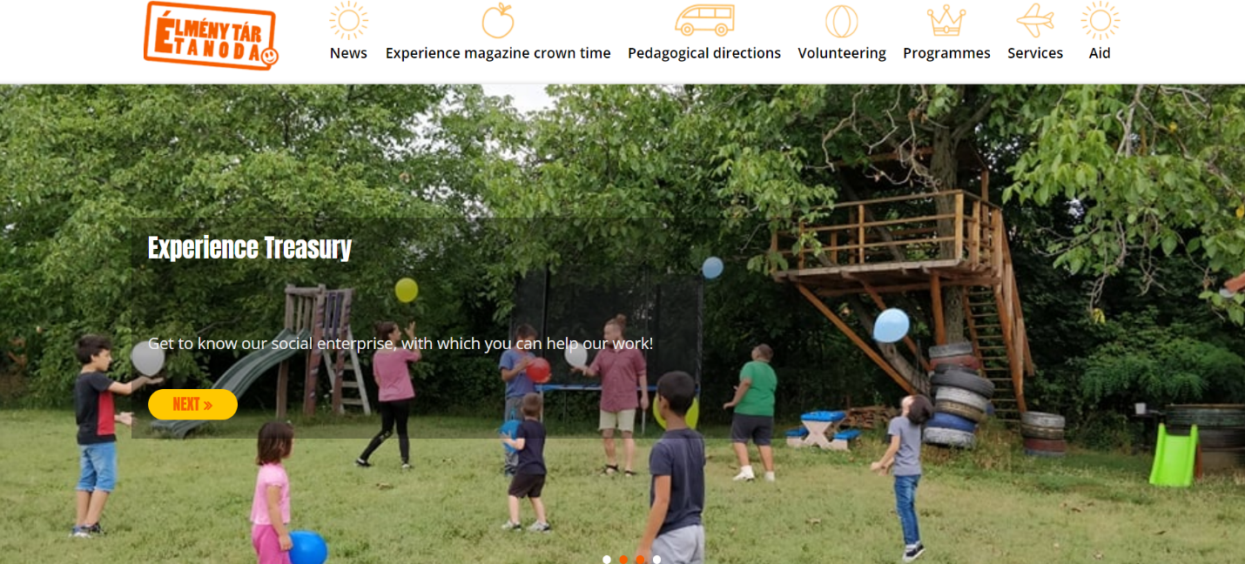

12:00 - 13:00 Gandhi High School
Roma ethnic school, the only one in Europe. It was originally an initiative based on human rights values. They help young Roma to get higher education.
http://eandhigimi.hu/
Gandhi Gymnasium - Gandhi High School in Pécs, Hungary, was founded by donations from several private sector individuals and further donations from other organizations in 1992, becoming the first Roma high school in Hungary to be active since 1994. We provide our students with conditions for modern education, and in the context of education, we use alternative methods. We prefer cooperative and project work, we consider it important to develop team spirit. In their free time, the students of our school get involved in the hectic cultural life of Pécs.
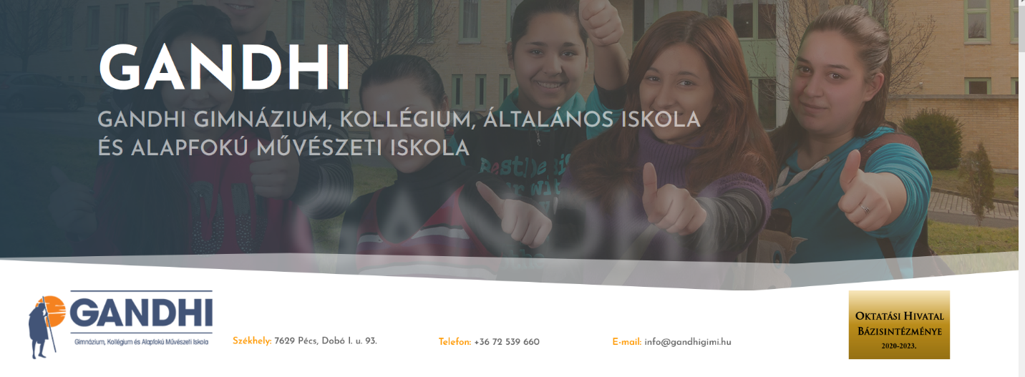

13:00 - 14:00 lunch at the restaurant Kóstolda Roma
A restaurant with traditional Roma food, run by a Roma NGO that empowers women and helps them in the labor market.
https://www.facebook.com/KKC3%B3stolda-4043 17776420397 /
Kóstolda - The aim of the initiative is to create a meeting place where the non-Roma population could learn about the customs, values and, no less important, the food of the Roma population. This is a project in which Roma participate, building mutual trust and acceptance, and strengthening the credibility of this group among the citizens of Pécs. We hope that this will lead to a more positive opinion of us, the Roma, in the eyes of the majority society, and that it will be possible to have a kind of dialogue between Roma and non-Roma. We sincerely believe that a good meal can bring different cultures and people together.

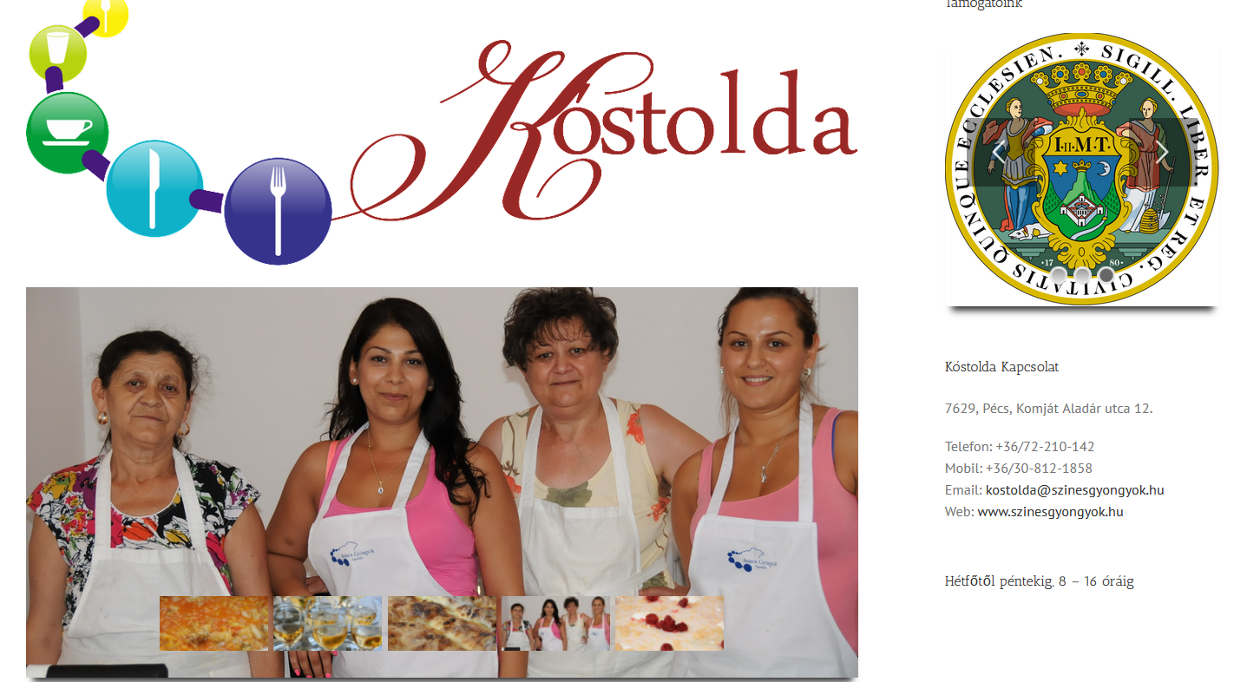

14: 00— 14:45 Uccu Alapítvány
The main mission of Uccu is to suppress prejudices and negative stereotypes related to the Roma, so that we can all live in a more tolerant and open society. Uccu organizes workshops on Roma identity in schools, all volunteers are young Roma.
https://www.uccuaIapitvany.hu/en/
Uccu Alapítvány - organizes workshops on Roma identity for young people. All of their volunteers are young Roma, working to build community.- Interactive sessions on Roma culture and identity Uccu provides an opportunity for primary and secondary school students to meet and talk to Roma youth. Uccu’s volunteer teaching staff primarily provides interactive lessons on Roma identity and culture, to students aged 10 to 19 using non-formal education tools. During the lecture, we strive for students to gain as much information and personal experience about the Roma and to be as open as possible to each other and to the outside world.

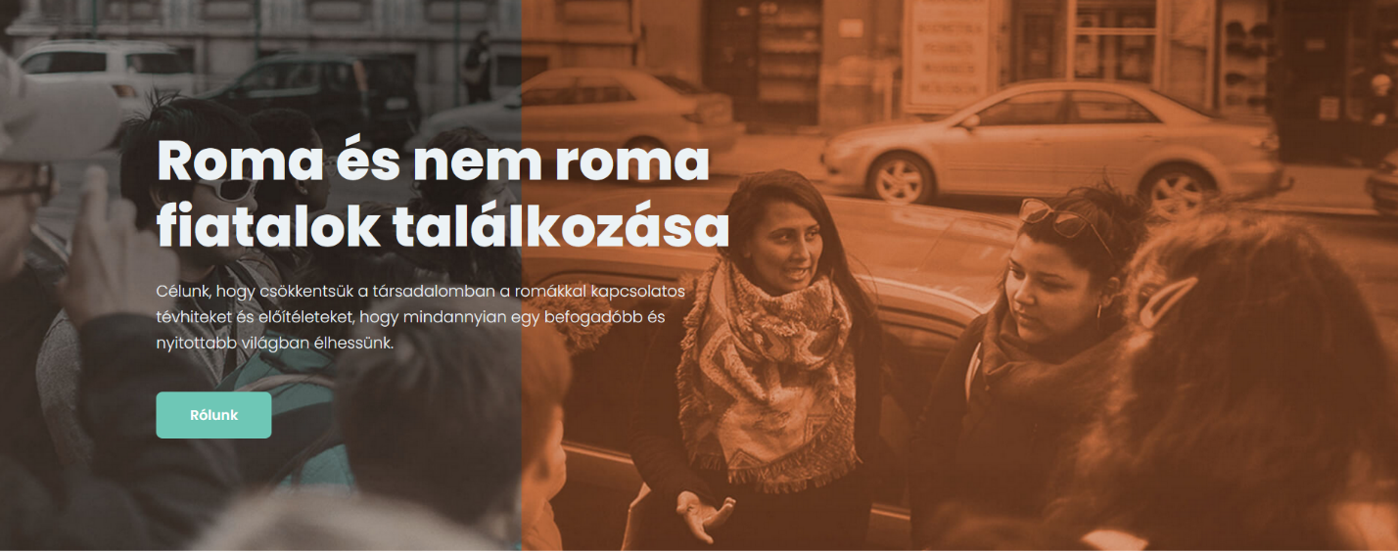

14:45 - 15:30 PERSZE
The Evangelical Roma Faculty in Pécs helps Roma university students. This means a community that helps you during your studies, but also training and mentoring. They are linked to Roma studies at the University of Pécs, but students come from various faculties.
The goal of the Evangelical Roma High School in Pécs is to educate young intellectuals who combine professional excellence with empathy and activism for social issues, thus supporting the coexistence of Roma and non-Roma. To this end, by providing a high level of education, the faculty helps its students to achieve outstanding results in their field, caring for talent and, if necessary, compensating for shortcomings. The goal of the college is to implement a complex development program that contributes to the successful completion of higher education students, in general, reducing dropout rates, while supporting the active participation of students in academic life; It pays special attention to the personal and professional development of its members, and places great emphasis on strengthening the Roma- Hungarian dual identity.
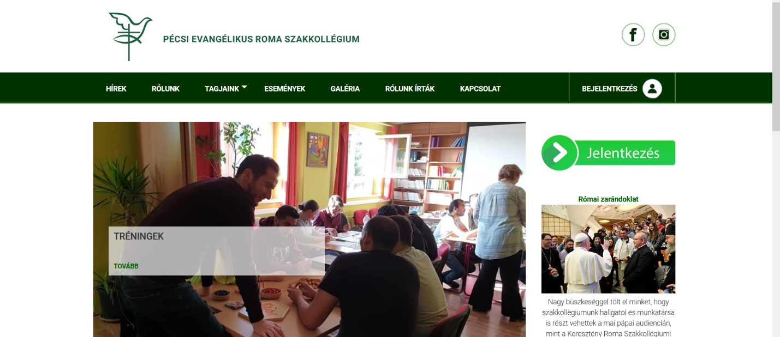

15:30 – 16:30 Exploring the Pecs city center

